Final Project

Virtual Boy Failure

MSIS 643: Decision and Risk Analysis

Professor Jeffrey Keisler

Fall 2023

Group 2: Tra (Joey) Hoang, Duc Pham, Kaoshal Rathod, Sathwika Yelamoni

**Project Memo**

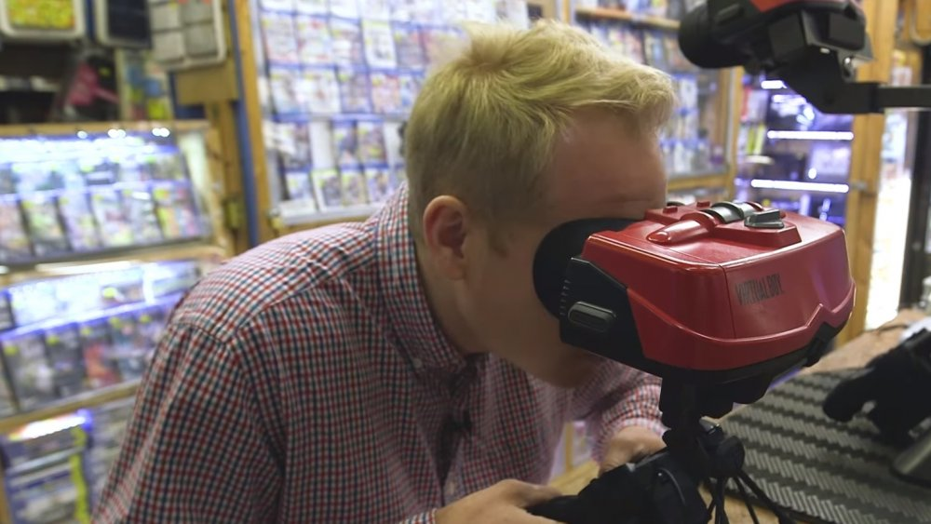

**Title of Failure Business Case**: Virtual Boy

**Why are we interested in this case (Overview)?**

Nintendo is one of the biggest game companies in the world with many successful consoles such as Nintendo Switch, Nintendo 64 and Nintendo 3DS. However, the Virtual Boy stands out as one of Nintendo's most infamous failures, as indicated by various articles. Despite Nintendo's overall success, our interest lies in uncovering the reasons behind this failure. Assuming the role of a Nintendo decision-maker, we aim to construct a model that elucidates the uncertainties, values, and decision options prevalent during that period. Through this exploration, we seek a comprehensive understanding of the business decision-making process and the risk analysis associated with a genuine business case.

**Rationale for the frame:**

Analyzing the Virtual Boy’s failure through the frame of all bad product strategies provides a comprehensive understanding of the systemic issues. By examining the hardware design flaws, the limited game library, ineffective marketing, and the high price point, it becomes clear that the failure was not isolated to a single aspect but rather a combination of factors that contributed to the overall lack of success in the market. This frame allows for a holistic evaluation of the product's shortcomings and provides insights into how these issues collectively led to the Virtual Boy's failure.

**List of Issues:**

1. Poor Sales Records:

- 770,000 units sold, recorded as the worst-selling console of all time. Only lasts for 1 year.

2. Unprepared for Virtual Reality Mass-Market in the 1990s:

- The model was not aligned with the virtual reality expectations of the 1990s consumer base. Basically the idea was good but the tech at that time was not able to fulfill the idea.

3. Design Flaws:

- Bulky headset design.

- The graphic only contains red and black color so cannot use it for a long time.

- Bad mechanism (have to use a stand)

- High price ($179) compared to its design and features. They reduced the price to $99 but still had to discontinue the product two months later.

4. Failure to Meet User Expectations:

- Primitive graphics led to unmet virtual reality expectations.

- Not user-friendly and posed health risks (neck pain and eye strain).

5. Limited Game Library:

- Only 22 games available, lacking a strong library.

6. Market and Media Opposition:

- The market and media were against the Virtual Boy from its inception.

7. Misleading Marketing:

- Commercial failure as it delivered 3D, not true virtual reality.

8. Inferior Quality Compared to Other Nintendo Consoles.

9. Money invested in technology but not bringing good results:

* Paid over $10 million for exclusive right tech.

**Hierarchy of Decision Issues:**

1. Policy Decision:

* Should we choose the renovated decision where “Console is wearable, display is full color, Nintendo’s game library is big and no third-party game”?

2. Strategic Decision:

- What is the strategy should be made between “the original decision” vs “the decision from our group”

3. Downstream Decision:

- How can we enhance the model concerning its design, display, game library and third-party game?

**Model overview**

Decision:

Console

Display

Nintendo’s game library

Third-party game

Strategy table:

Strategy 1: The original decision

Strategy 2: The decision from our group

Uncertainty:

Market acceptance

Demand (Unit sales quantity)

Value:

Cost per Unit (driver node)

Revenue per Unit (driver node)

Profit (metric node)

Display Costs

Third-party costs: the money Nintendo will cost for adding third-party games per console

**Influence diagram:**

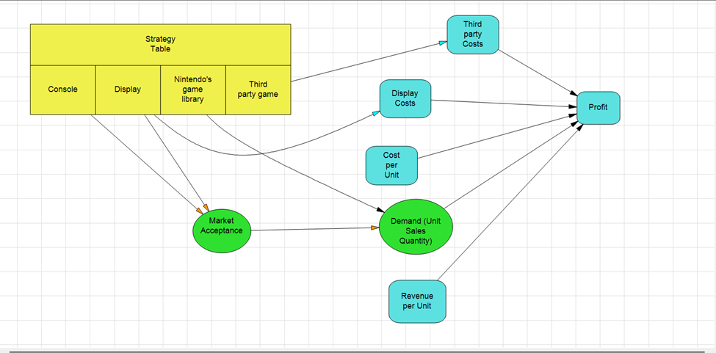

**Strategy Table:**

**Policy Tree:**

A tool for decision analysis, the policy tree plots possible outcomes of different strategies or choices, making it easier to assess them. Examining various approaches in the case of Virtual Boy, such as wearable design, full-color display, game library expansion, and enlisting the help of outside developers, reveals possible results and their estimated values. This thorough analysis aids in identifying the best course of action or combination of courses of action. The second strategy, which has a wearable console, a full-color display, a large Nintendo game library, and no third-party games, is the best option, according to the policy tree, with an expected value of 136200.

**Risk profile:**

The risk profile sheds light on the possible consequences and related risks of the choices taken. It aids in comprehending the range of earnings or losses that Nintendo might anticipate in light of various circumstances. The risk profile for Virtual Boy shows a profit range of $30,000 to $240,000, illustrating the possible variation in earnings depending on elements such as cost per unit, unit sales, and other significant variables.

**Tornado chart:**

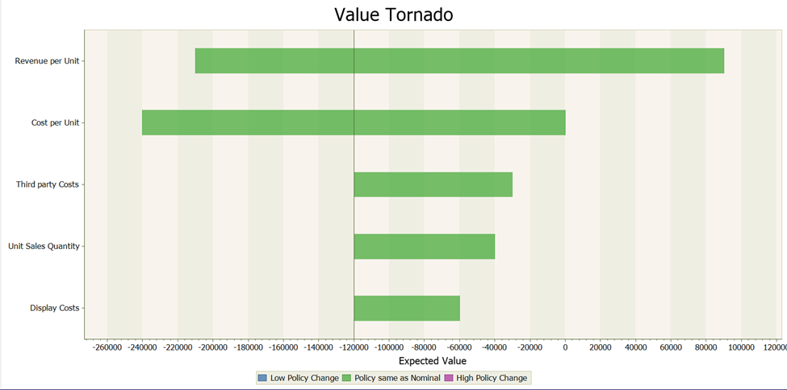

The Tornado Value Chart illustrates, graphically, how various factors affect the ultimate result, in this case, Nintendo's profit. It pinpoints the elements that most significantly affect profitability. The figure in the context of Virtual Boy emphasizes that profit is primarily influenced by cost per unit and revenue per unit, underscoring their crucial role in determining the product's success or failure. The total expected value is also greatly influenced by display expenses, unit sales quantity, and third-party costs.

Together, these analytical tools show how the Virtual Boy's failure was caused by various factors, including pricing strategies, game library, marketing, and hardware design. A retrospective view is made possible by the decision analysis model, which provides insights into how various choices might have changed the course of the product. This analysis, which emphasizes the significance of elements like creative design, a variety of game offerings, strategic alliances, and successful marketing in assuring success in the cutthroat gaming market, could direct future product strategies.

By applying these models to analyse past failures, companies such as Nintendo are able to improve their decision-making processes, anticipate risks, optimize strategies, and ultimately increase the likelihood of success for their upcoming products and ventures.

These can help to determine the uncertainty that impact to the four strategies in strategy table.

**VOIC analysis:**

A decision-analytic technique called value of information/control (VOIC) can be used to measure the advantages of obtaining more data to support these kinds of analyses, which can aid in a variety of manufacturing decisions.

For the virtual boy model the VOIC analysis is as shown above which contains all the control that is done with respect to the Estimated Value of perfect information/Control. The Demand of the product has a value of control in between 3200 to 3300. Demand is calculated as unit sales per quantity. Market Acceptance has more estimated value of value of info/control when compared to the demand which is in between 6300 to 6400.

Enhance the Virtual Boy's market position as a 3D console, a focus on improving marketing strategies is recommended.

**How the model would have worked on the original decision?**

When Nintendo first released the Virtual Boy, their cost per unit was $180, and their unit sales were 770000. However, their development costs had already exceeded $1 million, and their marketing efforts had failed, so the price was later reduced to $99 per console after all of their discounts. This suggests that their overall profit margin might not have been sufficient to support future product releases. One of the possible reasons for the discontinuation of Virtual Boy was the Nintendo 64, which was released at the same time and sold 4.7 million consoles annually. Thus, by applying the aforementioned decision analysis model, we may plan product strategies in a different way. We can make some new decisions with this model, like making the console wearable and the display colorful, expanding the game library, and requesting more games from third-party developers to draw in more players and enhance Virtual Boy's marketing as a 3D console. My team's decision analysis model was used to analyze the poor performance of the Virtual Boy and provide a framework for how to approach this product better. This model can be used in many business cases, such as:

**1. New product production:**

* **Pre-release** **product evaluation model** helps in finding risks before releasing the product to the market as well as reduces decision errors in pricing, features, design and marketing strategy.
* **Marketing strategy to enter the market:** variables such as competitors, customer needs or prices are all within the capabilities of this model and it can find the best solution when in a market. new or an

**2. Business Planning that is Strategic:**

* **Diversification strategies:** The model can assist businesses thinking about expanding into new markets or diversifying their product line by evaluating the risks and viability of various options.
* **Market positioning:** The optimal strategy for market positioning and competitiveness can be found by examining a variety of factors, including features, pricing, and marketing tactics.

**3. Resource Allocation and Risk Management:**

* **Resource allocation:** By identifying crucial elements that affect profitability, such as production costs and revenue per unit, decision-makers can use this model to allocate resources effectively.
* **Risk mitigation:** By using the value tornado chart to identify high-impact variables, risk mitigation strategies can be prioritized, and efforts can be directed toward areas with the greatest possible potential impact.

**4. Branding and Marketing Techniques:**

* **Marketing campaigns:** Optimizing outreach and advertising efforts can be aided by evaluating how marketing strategies affect overall profitability.
* **Brand perception:** Strengthening market presence and improving brand strategies can be achieved by assessing how product features, design, and branding affect consumer perception.